TARİH : 27.07.2018
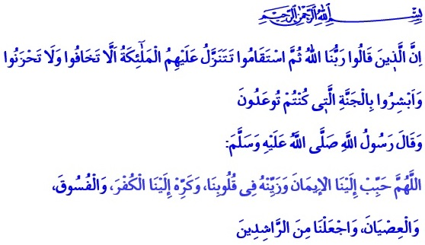
THE RELATIONSHIP BETWEEN FAITH AND DEEDS
Honorable Believers!
One day when the Messenger of Allah (s.a.w.) was riding his camel, he called out to Mu’adh bin Jabal who was sitting behind him, “O Mu’adh!” Mu’adh replied, “Your word is my order, o the Messenger of Allah!” Our Prophet repeated, “O Mu'adh!" Mu’adh answered for the second time, “Your word is my order, o the Messenger of Allah!” This repeated for a third time and the Messenger of Allah said, “There is none who testifies sincerely that none has the right to be worshipped but Allah (s.w.t) and Muhammad (s.a.w.) is his Messenger, except that Allah (s.w.t), will save him from the Hell-fire.”
Dear Muslims!
On top of the most important blessings bestowed upon us by the Lord Almighty (s.w.t.) comes the faith. Faith stands for believing sincerely in the existence and unity of Allah, His Angels, His Books, His Prophets, the Day of Judgment, and the Qada and Qadar (the Predestination and the belief that all things, good or bad, come from Allah (s.w.t.). It is to acknowledge sincerely and profess all truths conveyed to us by the Prophet of Mercy (s.a.w.). It is to be submitted to Allah (s.w.t.) with loyalty and devotion.
Venerable Believers!
Every human is born on al-Fitra (the Islamic disposition). Fitra means that every person has an essence of creation that is inclined to faith and goodness. Those who choose faith, Islam and beneficence (ihsan) are blessed with unending blessings. Allah (s.w.t.) is always with believers who have complete faith and trust in Him. Allah (s.w.t.) protects and helps them, and never leaves them alone.
Faith adds meaning to people’s life, gives them an awareness of living in accordance with the purpose of creation, shapes their behaviors, directs their ideas and decisions. Faith makes people strong, patient and enduring against the hardships of life. Faith removes solitude, weakness and hopelessness. Faith helps people be fully aware and grateful for the blessings.
Dear Believers!
Faith in Allah (s.w.t.) requires us to live according to our Prophet’s sunnah in all aspects of our lives. Defining a believer as “one from whose tongue and hand the people are safe”, the Messenger of Allah (s.a.w.) mentions doing beautiful deeds, keeping promises made, not betraying what is entrusted, treating well the guests, and speaking of the good as the manifestations of faith. When a companion asked him (s.a.w.) to “tell him something about Islam that later he never has to ask anybody else about it”, he (s.a.w.) replied, “Say I affirm my faith in Allah (s.w.t.), and be steadfast.”
My Brothers and Sisters!
What keeps our faith alive is our good deeds, what makes it to reach maturity is good morals. Our Lord (s.w.t.) heralded this to everyone who believes and does right, good and beautiful deeds in line with His approval: “Whoever does righteousness, whether male or female, while he is a believer - We will surely cause him to live a good life, and We will surely give them their reward [in the Hereafter] according to the best of what they used to do.” Our Beloved Prophet (s.a.w.) remarked that the connection between faith and good morals is indispensable as follows: “The most complete of the believers in faith is the one with the best character among them.”
Honorable Believers!
Faith and good deeds are the most valuable wealth we have that will help us attain the mercy of Allah in the Afterlife. It is expressed in the Holy Qur’an, “Indeed, those who have said, “Our Lord is Allah " and then remained on a right course - the angels will descend upon them, [saying], "Do not fear and do not grieve but receive good tidings of Paradise, which you were promised.”
Every believer who reflects their faith on their life with good deeds and good morals is an addressee for the good tidings of Allah (s.w.t.) as long as they turn towards Allah sincerely and say  “Sufficient for us is Allah, and [He is] the best Disposer of affairs.” in every situation.
Venerable Believers!
Faith is a whole. Declining to believe even one of the fundamentals of faith means to be faithless, which is a great catastrophe, because being faithless distances a human from the purpose of creation and leads to a meaningless life. It damages the feeling to be self-sacrificing for the noble ideals. Those who do not believe in the Power of Allah, the guide sent and the truth promised by that Power, and the existence of the unending life cannot find peace and happiness. They will be deprived of Allah’s (s.w.t.) mercy and help in the Afterlife.
Brothers and sisters!
Let us know the value of our faith. Let us have the kind of true faith that glorifies our souls, reinforces our servitude to Allah (s.w.t), protects us from being a slave to our nafs-driven desires, build our future just as our present day. Let our faith prosper our world and our afterlife.
I finish my khutbah with the prayer of our Beloved Prophet (s.a.w.), “O Allah! Make us love faith, adorn our hearths with faith! Stop us from loving blasphemy, disobedience and rebellion, make them seem vile! Make us be among the ones on the right path!”

Bukhari, ‘Ilm, 49
Nasa’i, Iman, 8
Muslim, Iman, 62
Nahl, 16:97
Tirmidhi, Rada, 11
Fussilat, 41:30
Al-i Imran 3/173
Ibn Hanbal, III, 424 Issued by: General Directorate of Religious Services

